UNIVERSITY OF ENGINEERING AND
TECHNOLOGY, LAHORE



SUBJECT:
Programming Fundamentals
SUBMITTED BY:
Waila Munir
2026-
Section A
SUBMITTED TO:
Miss Sawera Naz

DEPARTMENT OF COMPUTER SCIENCE UET
LAHORE
Tasks No. 01
File Deletion Practice
- Create study folder
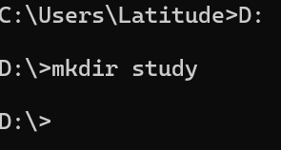

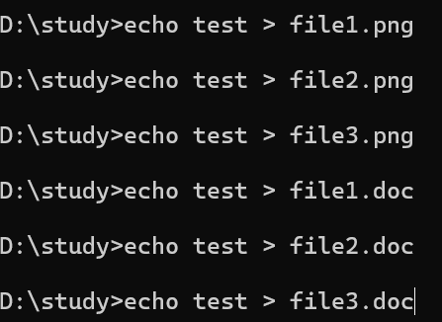
- Create some dummy.png and .doc

- CLI command to delete all .png files and .doc
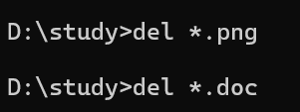

- Create subfolders and create more .png and .doc inside subfolders
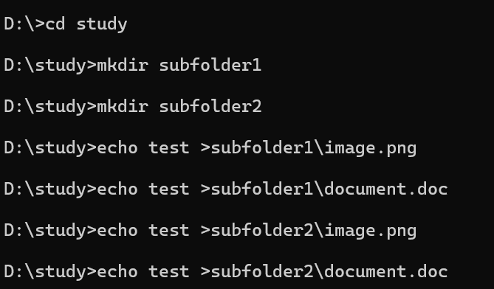

- Delete all .png and .doc from subfolders
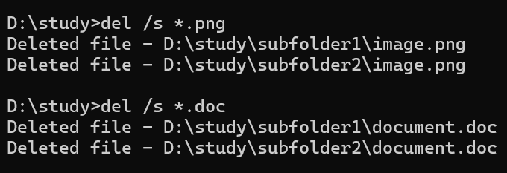

- Confirm work with dir command
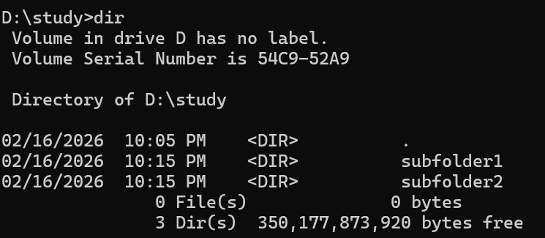

Task NO. 02
File Copy and Move Practice
- Create programming file in study folder
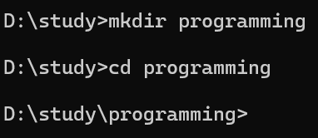

- Create text files inside programming folder
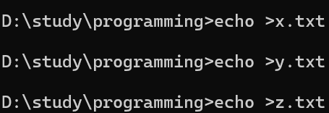

- Copy all three files into I2C folder
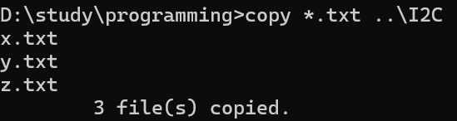

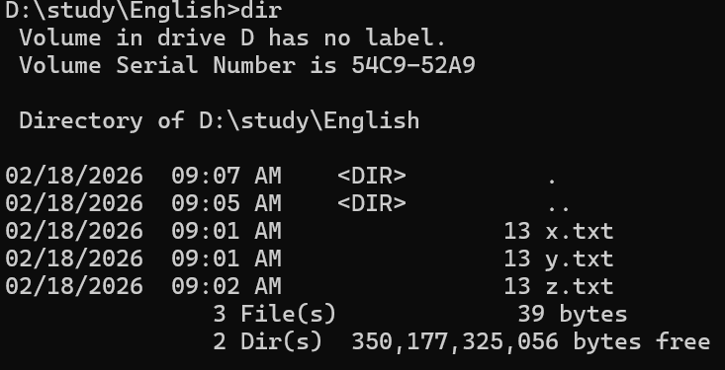
- Confirm the file location using dir command

Task NO. 03
File Renaming Challenge
- Open study folder
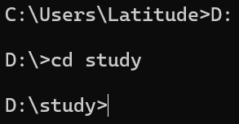

- Create text file named notes.txt
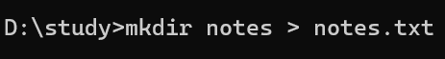

- Rename it to notes_old.txt using CUL command
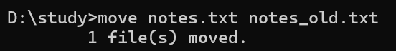

- Move renamed file into the programming folder
Verify changes with the dir command
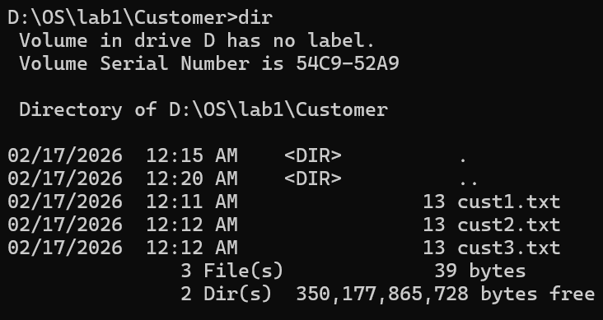

Task NO. 04
Folder Cleanup Task
- Create a folder Temp inside Study directory


- Create two dummy files inside Temp folder
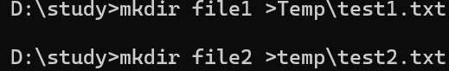

- Delete entire Temp folder using CLI
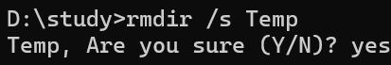
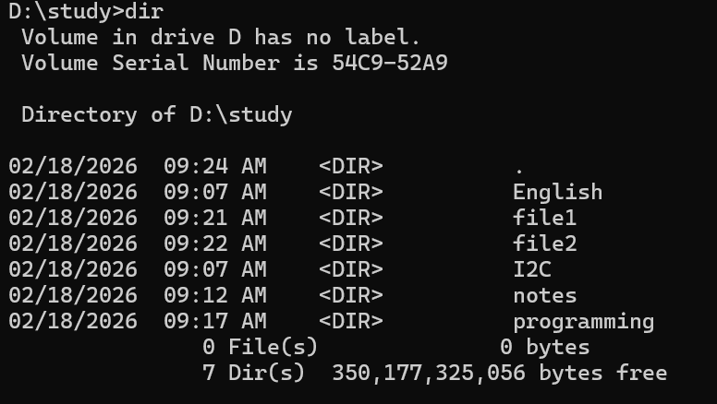

- The folder has been removed successfully

